Regularization

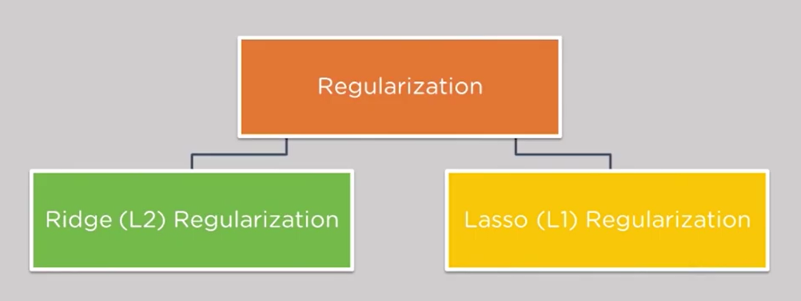

Regularization

* A technique to reduce overfitting problem.

Lasso Regularization or L1-Regularization

* It is preferred when we are fitting a linear model with fewer variables.

Ridge Regularization or L2-Regularization

* It is useful when we have many variables with relatively smaller data samples.